a

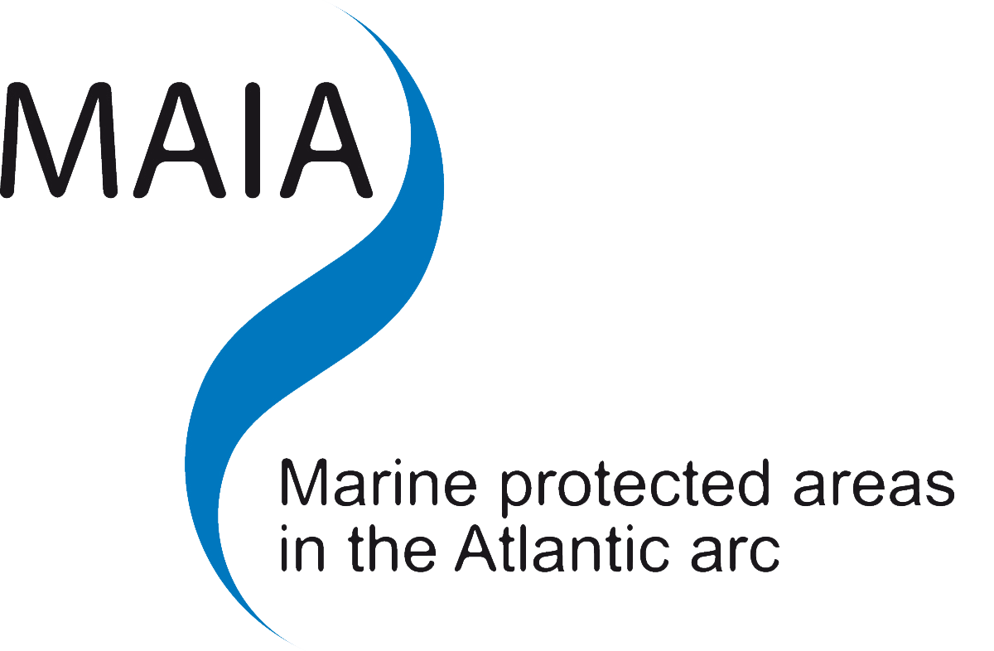

|  |  |
| --- | --- |
|  |  |
|  | **Tools for MPA Governance: Management Plans**  MAIA INTERNATIONAL WORKSHOP  **11 - 13 June 2012**  Fundación Pedro Barrié de la Maza  A Coruña, Galicia, Spain  Follow the Workshop on-line: [www.campusdomar.es](http://www.campusdomar.es) |

AGENDA

|  |
| --- |
| The purpose of the MAIA project is to create a network of MPA managers of the Atlantic arc. The aim of this network is to be involved in the development of a representative, consistent, efficient and accepted network of Marine Protected Areas.  Through the MAIA project, an analysis of the management documents and measures and their implementations in the Marine Protected Areas of the Atlantic arc has been completed. Based on the results of this analysis, a guideline for the designing of management plans adapted to the Atlantic arc MPAs has been proposed. This technical workshop will focus on the management of MPAs and will be a great opportunity to discuss results of analysis done in the MAIA framework, proposal guideline and share approaches within MAIA partner countries.  The key objectives for the workshop are:   * Share methods and experiences in designing MPAs management plans inside and outside the Atlantic arc. * Exchange fieldwork experiences in the implementation of MPAs management measures being undertaken across partners in the MAIA area and other relevant cases. * Share experiences focused in specific management issues in MPAs.   There will be simultaneous translation into French, Spanish, Portuguese and English which will ensure that all delegates are able to fully participate in the discussions to support the production of best practice outputs.  The MAIA partnership is led by the French MPA Agency and incorporates organisations from France (CNPMEM and AGLIA); Spain (University of A Coruña, Government of Galicia); Portugal (IPIMAR and ICNB); UK (JNCC, Finding Sanctuary and Natural England). |

Day 1 (Monday, June 11th): **DESIGNING MANAGEMENT PLANS FOR MPAs**

09:00 Meeting and inscription (please sign the attendee sheet)

09:30 Welcome

* *Ricardo Cao, Vice-Chancellor of Research, University of A Coruña (Spain)*
* José Molares, Subdirección Xeral de Ordenación dos Recursos Mariños, Xunta de Galicia (Spain)
* *Amandine Eynaudi, MAIA Project Coordinator, Agence des aires marines protégées (France)*

Morning session

Chairman:

Juan Freire, University of A Coruña (Spain)

**10:00 Introduction to session: General considerations for the design of MPA management plans**

* *Gonzalo Cid, NOAA-NOS International Program Office (USA)*

10:20 Q & A

**10:40 Global analysis of management plans of the Atlantic Arc MPAs**

* *Inma Alvarez, University of A Coruña (Spain)*

11:00 Q & A

11:10 Tea & coffee break

11:30 Experiences and feedback from designing a management plan (*DOCOB*) for marine SCI in France

* *Sophie Lecerf and Antonin Hubert, facilitators/MPA managers of Penmarc’h and Plateau du Four SCIs (France)*

11:50 Q & A

12:00 Working towards possible CFP fisheries management measures for UK Sites of Community Importance beyond 12 nm

* *JNCC (UK)*
* *Michael McLeod, Marine Scotland (UK)*

12:20 Q & A

12:30 Experience in designing and developing management plans in Galician MPAs of fishing interest in cooperation with stakeholders

* *Patricia Verísimo & Duarte F. Vidal, University of A Coruña (Spain)*

12:50 Q & A

13:00 Portuguese experience on management plan building-up, implementation and revision for national Marine Protected Areas

* *Teresa Leonardo, ICNB (Portugal)*

13:20 Q & A

13:30 Lunch time

Afternoon session

Chairman: Gonzalo Cid, NOAA (USA)

15:00 OSPAR developments regarding management planning for MPAs beyond national jurisdiction (ABNJ)

* *David Johnson, OSPAR Executive Secretariat*

15:20 Q & A

15:30 Proposal of guidelines for the designing of management plans adapted to the Atlantic Arc MPAs based on the results of MAIA study

* *Inma Alvarez, University of A Coruña (Spain)*

15:50 Tea & coffee break

16:10 Open floor discussion – Key point for success in designing a management plan for MPAs

* *Facilitator: Juan Freire, University of A Coruña (Spain)*

18:00 Summary and Close

* *Juan Freire (Spain) and Gonzalo Cid (USA)*

19:30 **Visit to the Finisterrae Aquarium**

Day 2 (Tuesday, June 12th): **FOCUS ON SPECIFIC MANAGEMENT ISSUES IN MPAs**

8:30 Meeting, greeting and inscription (please sign the attendee sheet)

Morning session

Chairman:

José Molares, Xunta de Galicia (Spain)

08:40 Marine Natural Park of Iroise management plan first year of implementation experience

* *Thierry Canteri, Parc naturel marin d’Iroise (France)*

09:00 Q & A

09:10 Considering Seabirds in Marine Environment Management

* *Nuno Barros, FAME project, Portuguese Society for the Study of Birds (Portugal)*

09:30 Q & A

09:40 Tea &coffee break

10:10 Overview about fisheries management measures in MPAs, review of approach in different European countries

* **Belgian experience:** *Jochen Depestele, Institute for Agricultural and Fisheries Research Animal Sciences Unit Fisheries*
* **Dutch experience:** *Ton IJlstra, FIMPAS project*
* **French experience:** *Hugues Casabonnet, Museum national d’histoire naturelle*

11:10 Q & A

11:40 Self-protection plan for oil spills in MPA in Andalucía

* *Esther Gordo Sanchez, El Estrecho Natural Park (Spain)*

12:00 Q & A

12:15 Summary and close

* *Yorgos Stratoudakis, IPIMAR (Portugal) or José Molares, Xunta de Galicia (Spain)*

Explanations for the visit of the Marine Reserve of fishing interest Ría de Cedeira: guided tour to the MPA by bus (If somebody is interested in diving in the MPA, please, let us know).

12:40 Lunch at Barrie de la Maza venue

14:00 Travel to Cedeira by bus

15:30 **Visit of the fish market**

16:45 **Visit of Fishers Association of Cedeira and afternoon snack**

17:15 **Roundtable session with representatives of MPA stakeholders and management body**

20:00 Travel to A Coruña by bus

21:00 Arrival to A Coruña

22:00 **Dinner in Domus restaurant** (inscription needed: pre-payment or by hand - dinner cost 35€/person)

Day 3 (Wednesday, June 13th): **MANAGEMENT PLAN IMPLEMENTATION**

09:30 Meeting, greeting and inscription (please sign the attendee sheet)

Morning session

Chairman: Tom Hooper, Seas Life (UK)

10:00 The balance between conservation objectives and the economic and social incentives of the Caribbean marine parks: a delicate but essential process to achieve sustainable management

* *Georgina Bustamante, Coordinator, Caribbean Marine Protected Area Management (CaMPAM) Network and Forum GCFI Board of Directors*

10:30 Q & A

10:45 How to integrate governance issues in management plan development and implementation

* *Lia Vasconcelos, Universidade Nova de Lisboa*
* *Catarina Grilo, Universidade de Lisboa (Portugal)*

11:15 Q & A

11:30 Tea &coffee break

11:50 Management as an adaptive process: Urdaibai Biosphere Reserve

* *Manu Monge, Urdaibai Biosphere Reserve (Spain)*

12:10 Q & A

12:20 Lyme Bay: developing conservation management in a contentious site in South West England

* *Roger Covey, Natural England (UK)*
* *Neil Wellum, MMO (UK)*

12:50 Q & A

13:00 Current status and challenges of management plan implementation for Azorean MPAs

* *Pedro Afonso, IMAR/DOP University of Azores (Portugal)*

13:20 Q & A

13:30 Lunch time

Afternoon session

Chairman: Manu Monge, Urdaibai Biosphere Reserve (Spain)

15:00 Experience in the implementation and performance measurement of MPA management plans

* *Gonzalo Cid, NOAA-NOS International Program Office (USA)*

15:30 Q & A

15:35 Linking MPA management with monitoring: reported global experience and insight from ongoing work at Arrabida (Portugal)

* *Yorgos Stratoudakis, IPIMAR (Portugal)*

16:05 Q & A

16:10 Open floor discussion – Key points for success in implementing a management plan for MPA

* *Facilitator: Manu Monge, Urdaibai Biosphere Reserve (Spain)*

18:10 Summary and Close

* *Manu Monge and Gonzalo Cid*

18:30 End of the Workshop