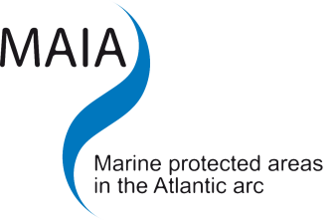

Management plan:
tools for MPA governance?

MAIA INTERNATIONAL WORKSHOP

11 – 13 June 2012

Fundación Pedro Barrié de la Maza
A Coruña – Galicia
Spain

PRACTICALITIES

- Event location
- How to get to La Coruña
Airlines
Bus from the airport Alvedro (A Coruña) to the city centre
Train from Santiago de Compostela to A Coruña
Bus from Santiago de Compostela to A Coruña.
- Accommodation options

Conference registration: www.maia-network.org/homepage/calendar/galicia2012

This international workshop is hosted by the University of A Coruña, in the framework of the European cooperation project MAIA Marine Protected Areas in the Atlantic arc.

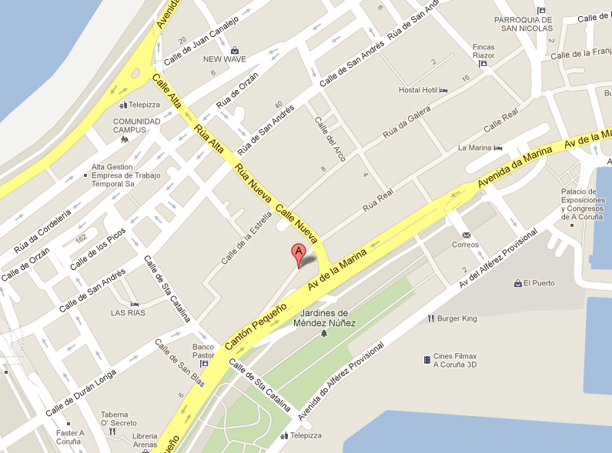
Event location

Fundación Pedro Barrié de la Maza
Cantón Grande, 9
15003 A Coruña.
Galicia – Spain

www.fundacionbarrie.org
Tel: +34 981 22 15 25

How to get to La Coruña
Airlines
Travel from the following destinations:
© 2012 Google

- London: Vueling airline (low cost). Direct fly to A Coruña + Taxi to hotel or a bus to A Coruña city.

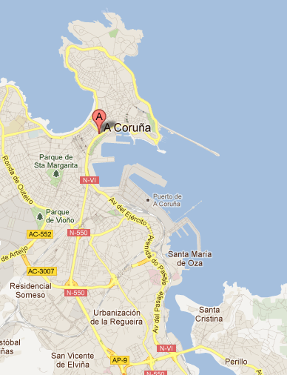
- Paris: Vueling airline (low cost). Direct fly to Santiago de Compostela + Train (about 30 min.) or bus to A Coruña city.

- All destination to A Coruña: Via Madrid or Barcelona (with Iberia, Spanair, Ryanair, Air Europa).

Bus from the airport Alvedro (A Coruña) to the city centre
For any question: +34 981 231 234, www.autoscalpita.es
Cost: 1,25 €.

Bus–stops:
Aeropuerto de Alvedro - Vilaboa - Corveira - Portazgo - Fábrica de Armas - Avda. Alfonso Molina - Plaza de Ourense (NH Atlántico hotel) - Casino (other hotels: 5-10 minutes walking) - Puerta Real.

Times

Monday to Friday (every 30 min)  A Coruña -> Airport to Alvedro: de 7.15 a 21.45 hours  Airport to Alvedro -> A Coruña: de 7.15 a 21.45 hours | Saturdays (every 60 min.)  A Coruña -> Airport to Alvedro: de 7.30 a 22.30 hours  Airport to Alvedro -> A Coruña: de 8.00 a 22.00 hours  Sundays and holidays (every 60 min.)  A Coruña -> Airport to Alvedro: de 8.30 a 22.30 hours  Airport to Alvedro -> A Coruña: de 9.00 a 22.00 hours

Train from Santiago de Compostela to A Coruña
See times and book on-line on: www.renfe.es
Tel.: +34 902 109 420

About 30 minutes. For instance:
Day Train/travel Output Arrival
10/06/2012 n°00085 Talgo 20:47 21:18

Bus from Santiago de Compostela to A Coruña.
See times and book on-line on: www.monbus.es
Tel.: +34 902 29 29 00

June 10, 2012
Output of Santiago de Compostela Arrival in A Coruña
09:58 11:00
11:58 13:00
12:58 14:00
15:23 16:25
16:58 18:00
18:58 20:00
19:58 21:00
22:28 23:30

Accommodation options

HOTEL ZENIT
Comandante Fontanes, 19. 15003 , A Coruña, España.
http://www.zenithoteles.com/Home/Index/3/11/1/0/16

Room: 59,40 € (VAT included).
Buffet breakfast: 5,40 €/person

Tel.: +34 609 686 491 (ask for Iago Ferreiro for booking)
comercialcoruna@zenithoteles.com
Reservation code: “FACULTAD DE CIENCIAS”.

HOTEL NH ATLÁNTICO
Jardines Méndez Núñez s/n. 15006 La Coruña, SPAIN
www.nh-hotels.com

Double room for single use rate / night including breakfast 75€.
Double room rate / night including breakfast 85€.
VAT not included in rate: 8 %

Tel.: +34 981 226 500 (ask for Natascha Mosquera for booking).
nhatlantico@nh-hotels.com
Reservation code: “FACULTAD DE CIENCIAS”.

HOTEL HESPERIA
Juan Flórez, 16. 15004 Coruña, A (España)
www.nh-hotels.com.

Single room and Breakfast: 65€
Double room and breakfast: 75€
8% VAT not included

Tel.: +34 981 010 300
reservas@hesperia-acoruna.com
Reservation code: “FACULTAD DE CIENCIAS”.

HOTEL RIAZOR
Av. Barrie de la Maza, 29 A Coruña 15004 España.
http://www.riazorhotel.com/

Single room: 65,97€ breakfast and vat included.
Double room: 78€ breakfast and vat included.

Tel.: +34 981 253 400
reservas@hotelriazor.com
Reservation code: “FACULTAD DE CIENCIAS”

