 |  |  |  | 
Conservation objectives and definitions of favourable condition for designated features of interest
These Conservation Objectives relate to all designated features on the SSSI, whether designated as SSSI, SPA, SAC or Ramsar features. |  | Cornwall Devon & Isles of Scilly  Level 8 Renslade House  Bonhay Road  Exeter EX4 3AW  Tel:0300 060 1110  Fax: 0300 060 1120  Email: devon@naturalengland.org.uk

Name of Site of Special Scientific Interest (SSSI)
Braunton Burrows

Names of designated international sites
Special Area for Conservation (SAC) | Braunton Burrows
Special Protection Area (SPA) | Not applicable
Ramsar | Not applicable

Relationship between site designations
Braunton Burrows is a SAC for grey dunes (CG10, SD7-8, SD9b, SD11-12 and SD19), dunes with creeping willow (SD16), humid dune slacks (SD13-17), Petalwort Petalophyllum ralfsii, white dunes (SD5-6) and intertidal mud & sandflats. The SAC and the SSSI share the same boundary.

Version control information
Status of this Version  (Draft, Consultation Draft, Final) |  | Consultation draft v.3
Prepared by |  | James Diamond, Jeremy Barker
Date of this version |  | 27th January 2010
Date of generic guidance on favourable condition used |  | Bryophytes & lichens guidance 2005  Geological guidance 2001 (revised 2006)  Invertebrate guidance 2008  Littoral sediment guidance 2006  Lowland woodland guidance 2003  Sand dunes guidance 2004  Vascular plants guidance 2004
Other notes/version history |  | This updates the version of 25th February 2008 with revised geological guidance and more detailed site-specific targets, as well as new NE template
Quality assurance information
Checked by | Name: |  | Date:
Checked by | Signature

www.naturalengland.org.uk
Conservation Objectives and definitions of Favourable Condition: notes for users

Conservation Objectives
SSSIs are notified because of specific biological or geological features. Conservation Objectives define the desired state for each site in terms of the features for which they have been designated. When these features are being managed in a way which maintains their nature conservation value, then they are said to be in ‘favourable condition’. It is a Government target that 95% of the total area of SSSIs should be in favourable condition by 2010.

Definitions of Favourable Condition
The Conservation Objectives are accompanied by one or more habitat extent and quality definitions for the special interest features at this site. These are subject to periodic reassessment and may be updated to reflect new information or knowledge; they will be used by Natural England and other relevant authorities to determine if a site is in favourable condition. The standards for favourable condition have been developed and are applied throughout the UK.

Use under the Habitats Regulations
The Conservation Objectives and definitions of favourable condition for features on the SSSI may inform the scope and nature of any ‘appropriate assessment’ under the Habitats Regulations. An appropriate assessment will also require consideration of issues specific to the individual plan or project. The habitat quality definitions do not by themselves provide a comprehensive basis on which to assess plans and projects as required under Regulations 20-21, 24, 48-50 and 54 - 85. The scope and content of an appropriate assessment will depend upon the location, size and significance of the proposed project. Natural England will advise on a case by case basis.

Following an appropriate assessment, competent authorities are required to ascertain the effect on the integrity of the site. The integrity of the site is defined in paragraph 20 of ODPM Circular 06/2005 (DEFRA Circular 01/2005) as the coherence of its ecological structure and function, across its whole area, that enables it to sustain the habitat, complex of habitats and/or the levels of populations of the species for which it was classified. The determination of favourable condition is separate from the judgement of effect upon integrity. For example, there may be a time-lag between a plan or project being initiated and a consequent adverse effect upon integrity becoming manifest in the condition assessment. In such cases, a plan or project may have an adverse effect upon integrity even though the site remains in favourable condition.

The formal Conservation Objectives for European Sites under the Habitats Regulations are in accordance with paragraph 17 of ODPM Circular 06/2005 (DEFRA Circular 01/2005), the reasons for which the European Site was classified or designated. The entry on the Register of European Sites gives the reasons for which a European Site was classified or designated.

Explanatory text for Tables 2 and 3

Tables 2, 2a and 3 set out the measures of condition which we will use to provide evidence to support our assessment of whether features are in favourable condition. They are derived from a set of generic guidance on favourable condition prepared by Natural England specialists, and have been tailored by local staff to reflect the particular characteristics and site-specific circumstances of individual sites. Quality Assurance has ensured that such site-specific tailoring remains within a nationally consistent set of standards. The tables include an audit trail to provide a summary of the reasoning behind any site-specific targets etc. In some cases the requirements of features or designations may conflict; the detailed basis for any reconciliation of conflicts on this site may be recorded elsewhere.

Conservation Objectives

The Conservation Objectives for this site are, subject to natural change, to maintain the following habitats and geological features in favourable condition (*), with particular reference to any dependent component special interest features (habitats, vegetation types, species, species assemblages etc.) for which the land is designated (SSSI, SAC, SPA, Ramsar) as individually listed in Table 1.

Habitat Types represented (Biodiversity Action Plan categories)
Supralittoral sediment
Littoral sediment
Broadleaved, mixed and Yew woodland

Geological features (Geological Site Types)
Active process geomorphological (IA)

(*) or restored to favourable condition if features are judged to be unfavourable.

Standards for favourable condition are defined with particular reference to the specific designated features listed in Table 1, and are based on a selected set of attributes for features which most economically define favourable condition as set out in Table 2, Table 2a and Table 3
Table 1: Individual designated interest features
BAP Broad Habitat type / Geological Site Type | Specific designated features | Explanatory description of the feature for clarification | SSSI designated interest features | SAC designated interest features | SPA bird populations dependency on specific habitats |  |  | Ramsar criteria applicable to specific habitats
 |  |  |  |  | Annex 1 species | Migratory species | Waterfowl assemblage | 1a Wetland characteristics | 2a Hosting rare species &c | 3a 20000 waterfowl | 3c 1% of population
Supralittoral sediment | Strandline, embryo and mobile dunes: SD1, SD2, SD4, SD5, SD6 | Inc. SAC Shifting dunes along the shoreline with Ammophila arenaria (white dunes) (SD6) | * | *
Supralittoral sediment | Fixed dune grassland: SD7-SD12, SD19 | Inc. SAC Fixed dunes with herbaceous vegetation (grey dunes) (SD7-8, SD9b, SD11-12)
Supralittoral sediment | Dunes with Salix repens: SD16 (with Salix repens dominant) | SAC Dunes with Salix repens ssp. argentea (SD16)
Supralittoral sediment | Humid dune slacks: SD13-SD15, SD16 (in part), SD17 | SAC Humid dune slacks (SD13-17)
Supralittoral sediment | Petalwort Petalophyllum ralfsii | A Schedule 8 and SAC Annex II plant (a liverwort) | * | *
Supralittoral sediment | Vascular plant assemblage | Includes nationally rare and scarce species. See Appendix 1 for details | *
Supralittoral sediment | Lower plant assemblage | Lichen communities of sand dunes | *
Supralittoral sediment | Amber Sand-bowl Snail Catinella arenaria | A Schedule 5 mollusc | *
Supralittoral sediment | Water Germander Teucrium scordium | A Schedule 8 plant | *
Supralittoral sediment | Fen Orchid Liparis loeselii | A Schedule 8 plant | *
Littoral sediment | Mudflats/ sandflats | Mudflats and sandflats not covered by sea water at low tide |  | *
Broadleaved, mixed and Yew woodland | W1 Salix cinerea-Galium palustre & W6 Alnus glutinosa-Urtica dioica woodland, and transitions | Dune slack scrub and woodland | *
Active process geomorphological (IA) | Coastal geomorphology of England | One of the three largest sand dune systems in western Britain, and the one least affected by underlying geology or by afforestation. | *
NB. Features where asterisks are in brackets (*) indicate habitats which are not notified for specific habitat interest (under the relevant designation) but because they support notified species.
Table 2: Habitat extent objectives
Conservation Objective for habitat extent | To maintain the designated features in favourable condition, which is defined in part in relation to a balance of habitat extents (extent attribute). Favourable condition is defined at this site in terms of the following site-specific standards.
Extent - Dynamic balance | On this site favourable condition requires the maintenance of the extent of each habitat type (either designated habitat or habitat supporting designated species). Maintenance implies restoration if evidence from condition assessment suggests a reduction in extent.

Habitat Feature (BAP Broad Habitat level, or more detailed level if applicable) | Estimated extent (ha) and date of data source/ estimate | Site Specific Target range and Measures | Comments
Supralittoral sediment:  Strandline, embryo and mobile dunes | 11 hectares (1983) | No net decrease in extent from 11 hectares, subject to natural change. | If loss (or gain) of area is due to natural causes, this is not a decline in condition; but any significant loss due to human interference (e.g. sand extraction, visitor impacts) is to be regarded as unfavourable.  Increase in area is favourable unless related to coast protection.  Strandline may be absent in some years as a result of natural causes, but continued absence over the six year period would cause condition to be unfavourable.  Extent, particularly of embryonic dunes, may be subject to periodic and seasonal variation
Supralittoral sediment:  Fixed dune grassland | 658 hectares (1983) | No net decrease in extent from 658 hectares, subject to natural change.
Supralittoral sediment:  Humid dune slacks | 111 hectares, undifferentiated between humid dune slack & dunes with Salix repens  (1983) | No net loss of area from 111 hectares of slack vegetation (undifferentiated between humid dune slack & dunes with Salix repens), subject to natural change.
Supralittoral sediment:
Dunes with Salix repens
Littoral sediment | 303 hectares (1983) | No change in extent from 303 hectares of mudflats and sandflats not covered by seawater at low tide, allowing for natural succession/ known cyclical change. | Where there is a change in extent outside the expected variation or a change in the structure of the biotope leading to a loss of the conservation interest of the site, then condition should be considered unfavourable.
Broad-leaved, mixed and Yew woodland | 40 hectares (1983) | At least area 40 hectares of recent semi-natural stands maintained. Although their location may alter, stands should be concentrated towards and along the inland boundary of the site. | Stand loss due to natural processes is acceptable. Stand destruction may occur if the understory and ground flora are irretrievably damaged even if the canopy remains intact. As a guideline, loss can be defined as the loss of 0.5 hectares.  20% canopy cover is conventionally taken as the lower limit for an area to be considered as woodland.

Audit Trail

Rationale for habitat extent attribute

(Include methods of estimation (measures) and the approximate degree of change which these are capable of detecting).
All extent information comes from the 1983 NCC habitat mapping project. See Appendix III, map 3 for the distribution of humid dune slacks and of dune slacks with Salix repens and App. 3, map 8, which shows distribution & extent of mobile, semi-fixed and fixed dunes, dune slacks and scrub/ woodland.

Rationale for site-specific targets (including any variations from generic guidance)

Other notes
It may prove to be impossible to differentiate dune slack types from aerial photography.

The aim is to have a mobile mosaic of habitats within the site, with new areas of bare sand created and then allowed to rest and re-vegetate. This is currently achieved mainly through military training activity on the site, though is necessarily affected by training types and intensity. It is felt that an overall target of a maximum percentage of (ideally mobile) bare sand would allow for training needs, provided it remains within the limits set out above.

Visitor pressure (trampling) may help create bare sand, but is unlikely to allow the necessary recovery of the vegetation.

Part of the site is also now managed through HLS, with cattle and sheep grazing in three compartments (see App. III, map 2 for detail), which is intended to assist in controlling invasive scrub and reinstating some mobility to the dune habitats.
Table 2a: Species population objectives
Conservation Objective for species populations | To maintain the designated species in favourable condition, which is defined in part in relation to their population attributes. Favourable condition is defined at this site in terms of the following site-specific standards.
Population balance | On this site favourable condition requires the maintenance of the population of each designated species or assemblage. Maintenance implies restoration if evidence from condition assessment suggests a reduction in size of population or assemblage.

Species feature (species or assemblage) | Supporting BAP broad habitats | Population attribute (e.g. presence/ absence, population size or assemblage score) | Site-specific target range and measures (specify geographical range over which target applies i.e. site, BAP broad habitat or more specific) | Comments
Petalwort Petalophyllum ralfsii. | Supralittoral sediment (sand dunes). | Population size and distribution. | Species remains present, with at least 2,400 thalli in at least 8 colonies within humid dune slacks. | See Appendix III for map. Core areas for Petalwort are illustrated there.
Water Germander Teucrium scordium. |  | Population size and distribution. | At least 15,000 stems within nine slacks, within humid dune slacks & dunes with Salix repens. | Baseline taken from Vause (1982) and Proctor (unpublished 1984). See App. III for map illustrating key sites
Fen Orchid Liparis loeselii. |  | Presence/ absence. | The species remains present within humid dune slacks. | See App. III for map. This species has not been recorded at the site since 1988; but the species could reappear when suitable conditions reoccur.
Vascular plant assemblage (see Appendix I for spp). |  | Assemblage score. | Assemblage score maintained across BAP broad habitat (i.e. all sand dune and dune slack types present). | If all other targets are met but the species cannot be found then the feature should be referred to the Country Agency botanical specialists.  A number of the component species have gone unrecorded for many years: their presence requires confirmation (see notes for details).  See App. II for further detail regarding which species has been recorded in which unit.
 |  | Presence/ absence of species. | The component species should be present on the site.
Vascular plant assemblage (see Appendix I for spp). | Supralittoral sediment (sand dunes). | Niche availability. | Map, where possible.  Sufficient area of suitable habitat to maintain populations of VPA species.  No loss of extent of suitable habitat (spatial arrangement of habitat ‘patches’ may vary, year-on-year). | See below for details of applicable habitats, as well as maps in App. III regarding the distribution of VPA species.
 |  | Successful regeneration. | Identification of the species.  Count of individuals.  Presence of a range of young and old plants.  At least a minimum number/ proportion of young plants or seedlings or full seed heads or flowers. | This is important for understanding the viability of a population, but may be difficult to assess for some species.  The attribute should be considered applicable to Schedule 8 species only.
 |  |  | Marrubium vulgare, Medicago polymorpha & Trifolium glomeratum: at least 25% of the population producing ripe fruit. | Mainly annuals depending on good seed production from year to year for continued survival.
Vascular plant assemblage: Trifolium squamosum. |  | Population size. | At least a minimum viable population size present. | May occur in a restricted band so an estimate or measurement of the area covered is possible. Baseline survey required.
Vascular plant assemblage: Trifolium squamosum. |  |  | No more than 10% loss in overall coverage of the population.
Assemblage of lichens on sand dunes. |  | Presence/ absence. | Lichen assemblage maintained at least at Bomber Slack, Doughnut Ponds, Pebble Slack and Aspen Slack. | See notes regarding lichen assemblage in Table 3a for more detail.
Amber Sand-bowl Snail Catinella arenaria. |  | Presence/ absence and distribution. | Presence confirmed and population trend assessed at 10 sample sites within humid dune slacks, as indicated on appended map. | A monitoring protocol is available to follow. This protocol is outlined in this document (Table 3a).

Audit Trail

Rationale for species population attributes

(Include methods of estimation (measures) and the approximate degree of change which these are capable of detecting).
Populations of Petalwort, Sand-bowl Amber Snail, Water Germander and some of the vascular plant assemblage species have monitoring data gathered over the years; this informs the baseline population levels given above. Information regarding the extent and composition of the lichen communities of importance is less comprehensive, but sufficient also to provide a baseline.

Lichens, Sand-bowl Amber Snail and Petalwort should all be monitored by experienced surveyors. Some of the vascular plant assemblage species may no longer exist at the site, whilst for others there is as yet no distribution data.

Rationale for site-specific targets (including any variations from generic guidance)
The core population monitoring for Sand-bowl Amber Snail should occur on the ten slacks surveyed for the baseline population estimate (indicated in brown on map 4, Appendix III). The continued presence of the snail in any of the orange-coloured slacks is of importance, but should not be a monitoring priority. The monitoring targets and protocol have been taken from this baseline survey.

Vascular plant assemblage species with mapped distributions are shown on map 4, Appendix III. This should form a baseline for their distribution.

Other notes
The lichen interest of the site is not confined to lichens of sand dunes; several rare species and species of international responsibility occur in some areas of scrub and woodland (map 7, Appendix III). These should also be maintained.

The following information comes from the ‘Braunton Burrows National Nature Reserve flowering plant list 1977” in the site scientific dossier. This is the only comprehensive information apparently available with any indication of distribution or abundance of many of the vascular plant assemblage species. Further information regarding broad habitats in which the species are found has come from Ivimey-Cook (1984). Atlas of Devon Flora – flowering plants and ferns, and Stewart, A., Pearman, D.A. & Preston, C.D. (eds). (1994). Scarce plants in Britain.

The distribution of species by unit – where known – is summarised in Appendix II.

Vascular plant assemblage Schedule 8 species:
- Fen Orchid Liparis loeselii: the species was last recorded in “the NW corner of Braunton Burrows NNR” around 1987 (see map in Appendix III). The last flowering record dates to 1978 (source: species card in site scientific dossier). The species should be sought around new dune slacks or scraped areas, where the water table lies very close to the surface. Failure to find the species should not necessarily result in unfavourable condition, as the species has now not been recorded for many years. Habitat: humid dune slacks.
- Shore Dock Rumex rupestris: no details available (pre-1970 record). Habitat: strandline, embryo and mobile dunes.
- Water Germander Teucrium scordium: found locally in a number of wet dune slacks – see appended map for details. Habitat: humid dune slacks.
- Dune Gentian Gentianella uliginosa: records from herbarium specimens (1849, 1927) and rediscovered in 1999 (J. Breeds, pers. comm., British Red Data book of vascular plants, 1999). Habitat: humid dune slacks.
- Early Gentian Gentianella anglica: rare in wet slacks. Habitat: humid dune slacks.
- Sea Knotgrass Polygonum maritimum: no details available. May now be extinct in the county (pre-1970 record). Habitat: strandline, embryo and mobile dunes.

Vascular plant assemblage rare species:
- Sea Stock Matthiola sinuata: local but widespread in mobile dunes. See appended map. Habitat: strandline, embryo and mobile dunes.
- Round-headed Club-rush Scirpoides holoschoenus: locally common in damp slacks. Habitat: humid dune slacks.

Vascular plant assemblage scarce species:
- Sharp Rush Juncus acutus: abundant in damp slacks. Habitat: humid dune slacks.
- White Horehound Marrubium vulgare: single plants appear just above the strand line immediately west of the Broadsands boulders SS468/327 & about 6 plants occur erratically in the car park east of the boulders. A strong colony occurred up to the early 1990s at the site of the old lighthouse (SS458/325), but the area became overgrown (source: J. Breeds 2007, pers. comm.). Habitat: strandline, embryo and mobile dunes.
- Toothed Medick Medicago polymorpha: local in the fixed dune grasslands (‘dune pasture’). Habitat: fixed dune grassland.
- Round-leaved Wintergreen Pyrola rotundifolia maritima: locally common in wet slacks. Habitat: humid dune slacks.
- Sea Clover Trifolium squamosum: last known records are from 1972 in tetrads SS46 32 & SS46 34. New baseline search required. (Source: J. Breeds 2007, pers. comm.). Habitat: Strandline, embryo and mobile dunes?
- Dune Fescue Vulpia fasciculata: common in fixed dunes. Habitat: fixed dune grassland.
- Least Soft-brome Bromus hordaceus ferronii: (per. R. Hodgson, VC4 recorder, Feb. 2008). Habitat: fixed dune grassland.
- Sand Soft-brome thominei: rare in scrub. Habitat: fixed dune grassland.
- Early Marsh Orchid Dactylorhiza incarnata coccinea: common in wet slacks. Habitat: humid dune slacks.
- Variegated Horsetail Equisetum variegatum: locally common in wet slacks. Habitat: humid dune slacks.
- Sticky Stork’s-bill Erodium lebelii: a few plants in Broadsands, 2003-08 (J. Breeds, pers. comm.). May be overlooked elsewhere. Habitat: fixed dune grassland.
- Slender Bird’s-foot Trefoil Lotus angustissimus: (per. R. Hodgson, VC4 recorder, Feb. 2008). Habitat: fixed dune grassland.
- Fen Pondweed Potamogeton coloratus: (per. R. Hodgson, VC4 recorder, Feb. 2008). Habitat: humid dune slacks.
- Seaside Pansy Viola tricolor curtisii: locally common on fixed dunes. Habitat: fixed dune grassland.
- Clustered Clover Trifolium glomeratum: (old record, per. R. Hodgson, VC4 recorder, Feb. 2008). Habitat: fixed dune grassland.
Table 3a: Site-specific definitions of Favourable Condition
CONSERVATION OBJECTIVE FOR THIS HABITAT / GEOLOGICAL SITE-TYPE | To maintain the supralittoral sediment at Braunton Burrows SSSI in favourable condition, with particular reference to the strandline, embryo and mobile dunes (SD1, SD2, SD4, SD5, SD6), fixed dune grassland (SD7-SD12 and SD19), dunes with Salix repens (SD16), humid dune slacks (SD13-SD15, SD16 (in part) and SD17), the vascular plant assemblage, the lichen assemblage and the populations of Petalwort, Water Germander, Fen Orchid and Sand-bowl Amber Snail. Favourable condition is defined at this site in terms of the following site-specific standards:
Site-specific details of any geographical variation or limitations (where the favourable condition standards apply)

See appended maps for the distribution of these features on Braunton Burrows. These features are absent from unit 108.

Site-specific standards defining favourable condition

Criteria feature | Attribute term in guidance | Measure | Site-specific targets | Comments | Use for CA?
All sand dune communities: Strandline & embryo indicated as SE; Humid dune slacks as HD; Dunes with Salix repens as DS; and Fixed grass dunes as FD. | Vegetation structure: range of zones. | The width of zones estimated using transects extending from strandline to landward features.  Aerial photographs should be used as an aid, where available. | FD, SE: Zonation from beach to fixed dune intact over at least 95% of coastal frontage.  HD: All humid dune slack communities should be present, from embryonic dune slacks with a high percentage of bare ground to those with more closed vegetation and up to 33% cover of Salix repens.  HD: Early dune slack successional stages at least occasional. | Points may change due to natural dynamism but the overall diversity should not diminish.  If strandline is absent this may be acceptable if due to natural causes (see comment under Extent, Table 2).  The dune front may be vulnerable to heavy trampling/grazing by stock. | Yes.
All sand dune communities: Strandline & embryo indicated as SE; Humid dune slacks as HD; Dunes with Salix repens as DS; and Fixed grass dunes as FD. | Vegetation structure: bare ground. | Visual assessment of cover during structured walk and transects.  Aerial photographs should be used as an aid, where available. | SE: >5% bare sand or stones.  HD: <5% of total dune slack area.  DS: <10% of total dune slack area.  FD: <10% of total area.  DS and FD: no more than 15% of these areas in any one unit to be bare sand, ideally to be well distributed across the feature. | Bare (ideally damp) sand is important at this site for many of the vascular plant assemblage species, for Petalwort and for Sand-bowl Amber Snail. Areas of bare sand created by human induced disturbance should not increase.  Bare sand is created by recreation and military activities and by grazing. A shifting pattern of bare sand is desirable and should be spread widely across the site units, but there should be evidence that stabilisation is occurring. | Yes.
 | Vegetation composition: negative indicator species. | % cover of the entire feature. | SE, HD, DS and FD:  No one of the negative indicators more than frequent throughout the sward.  Singly or together the cover of negative indicator species no more than 5%. | Use: Ragwort Senecio jacobaea, Creeping Thistle Cirsium arvense, Spear Thistle C. vulgare, Common Nettle Urtica dioica, Perennial Rye-grass Lolium perenne, False Oat-grass Arrhenatherum elatius.  Urtica and Cirsium species indicate poor condition because of enrichment. Abundance of Senecio indicates overgrazing in summer. Lolium is indicative of agricultural improvement | Yes.
 |  | Aerial photographs, together with visual assessment of cover (modified DAFOR scale), using structured walk. | SE, HD, DS and FD:  Non-native species no more than rare. | Includes such species as Bay Laurus nobilis, Monbretia Crocosmia x crocosmiiflora and Sea Buckthorn Hippophae rhamnoides (see below also). | Yes.
 |  |  | SE & FD:  Hippophae rhamnoides should be absent | Sea Buckthorn Hippophae rhamnoides has been introduced and has proved very invasive. | Yes.
All sand dune communities: Strandline & embryo indicated as SE; Humid dune slacks as HD; Dunes with Salix repens as DS; and Fixed grass dunes as FD. | Vegetation composition: scrub/trees. | Visual assessment of cover (modified DAFOR scale), using structured walk or transects.  Aerial photographs should be used as an aid, where available. | HD, DS & FD:  Scrub/trees (excepting Salix repens in DS) no more than occasional or <5% cover.  Scrub and taller vegetation not encroaching on strandline, embryo and mobile dune habitats, or on fixed dune grassland or open dune slacks. | If scrub/tree species are more than occasional throughout the sward, they are soon likely to become a problem if grazing levels are not sufficient or if scrub control is not being carried out.  Scrub encroachment onto mobile dunes and fixed dune grassland threatens (or would threaten) many of the vascular plant assemblage species.  Scrub encroachment represents a significant threat to Scirpoides holoschoenus at Braunton Burrows, where the effects of a declining rabbit population (and perhaps also a falling water table) has been offset to some extent by annual mowing in winter to keep scrub at bay. | Yes.

Criteria feature | Attribute term in guidance | Measure | Site-specific targets | Comments | Use for CA?
Strandline, embryo and mobile dunes: SD1, SD2, SD4, SD5, SD6 +. | Physical structure: functionality and sediment supply. | Aerial photographs can be used, combined with information gathered from the site visit. | No further anthropogenic increase in factors leading to the decrease of natural mobility of the system. The natural circulation of sand and organic matter should be retained. | Natural processes, particularly sediment supply, may be interrupted or prevented by coastal protection or artificial stabilisation (currently groynes at Airy Point (SS457324), rock armouring along Crow Neck to Crow Point (c.SS463321-SS466319)). Accumulation of driftline organic material (seaweed etc.) is essential for trapping sand and initiating dune formation. Mechanical beach cleaning can adversely affect this process. | Yes.
 | Vegetation composition: typical species. | Visual assessment of cover (modified DAFOR scale), using structured walk and transects. | Maintain frequency of characteristic species of the main sand dune zones as follows:  Strandline: At least one species frequent and another occasional, from Sea Rocket Cakile maritima, Sea Sandwort Honckenya peploides, Saltwort Salsola kali, orache Atriplex spp.  Embryonic dunes: Sand Couch Elytrigia juncea at least frequent  Mobile dunes: Marram Ammophila arenaria at least frequent. | Communities may be dynamic in their distribution and are linked to the physical processes operating at the site. Embryo and mobile dunes are typically species-poor and monospecific stands are common.  Lyme-grass Leymus arenarius appears not to be present at this site (BSBI mapping and 1990 Sand Dune Survey of Great Britain report), so it has been removed as a characteristic species of embryonic and mobile dunes. | Yes.
 | Vegetation composition: condition and flowering/fruiting of foredune grasses. | Visual assessment of cover (modified DAFOR scale), using structured walk. | Healthy Marram Ammophila arenaria or Sand Couch Elytrigia juncea with abundant fruiting heads at least frequent. | If flowering is not frequent, dunes are no longer mobile and condition is unfavourable (however, if the species fail to flower across the entire region for reasons unconnected with sediment mobility, this should not apply). | Yes.
Strandline, embryo and mobile dunes: SD1, SD2, SD4, SD5, SD6 +. | Other negative indicators. | Visual assessment during site visit. | Vehicle damage or visitor damage at vulnerable locations (e.g. tracks, access points) should be absent or rare. | Notes should be made of the type of damaging activity, location and extent for future further assessment. Note that a proportion of disturbance of this kind is necessary to maintain populations of some of the vascular plants. However, levels of disturbance should not threaten erosion or cause significant blowouts. | Yes.
 | Indicators of local distinctiveness: vascular plant assemblage. | Presence confirmed during site visit at appropriate season. | Matthiola sinuata, Marrubuim vulgare: maintain presence at current locations (where known). | See map in Appendix III for current locations. New records should be mapped. | Yes.
 |  |  | Rumex rupestris, T. squamosum, Polygonum maritimum: establish presence/ absence at this site | R. rupestris not recorded since the 1960s, but has potential to reappear at the site; it may in fact be associated with humid dune slacks in any case.  P. maritimum may now be extinct in Devon. | Yes.
 | Reintroduced species. | Presence confirmed during site visit at appropriate season. | Sand Lizard Lacerta agilis population confirmed still present around Long Hollow. | Visual confirmation of presence may be sufficient, but transect, or transects, that establish the spread of the population from the reintroduction site would be preferred. | Yes.
Sea Clover Trifolium squamosum. | Hydrology. | Visual assessment. | Seasonally wet conditions which dry out during the summer months. | Included here as this appears to be the most suitable habitat for the species (which may in any case be extinct on-site: see notes following Table 2a). | Yes.

Criteria feature | Attribute term in guidance | Measure | Site-specific targets | Comments | Use for CA?
Humid dune slacks: SD13, SD14, SD15, SD16 (part), SD17. | Vegetation composition: forb/grass ratio. | Visual assessment of cover during structured walk and transects. | The sward should contain >30% cover of forbs and <70% cover of grasses. | Drying and eutrophication of the slack can be indicated by increase in ‘grassiness’. | Yes.
 | Vegetation composition: typical species. | Visual assessment of cover (modified DAFOR scale) during structured walk and transects. | Four or more typical species at least frequent and two or more others at least occasional.  Species include: Creeping Willow Salix repens, Watermint Mentha aquatica, Glaucous Sedge Carex flacca, Sand Sedge C. arenaria, Restharrow Ononis repens, Bird’s-foot Trefoil Lotus corniculatus, Lesser Spearwort Ranunculus flammula, Silverweed Potentilla anserina, Marsh Pennywort Hydrocotyle vulgaris, Calliergonella cuspidata, Marsh Bedstraw Galium palustre, Campylium stellatum, Variegated Horsetail Equisetum variegatum, Self-heal Prunella vulgaris, Bog Pimpernel Anagallis tenella  Bryophytes (e.g. Calliergonella cuspidata, Campylium stellatum) at least occasional. | Further research is required, as these indicators relate to fairly stable closed humid slack swards and not to the more open type. | Yes.
 | Vegetation composition: cover of Salix repens | Visual assessment of cover during structured walk and transects.  Aerial photographs should be used as an aid, where available. | Cover of Creeping Willow Salix repens not more than 33%. | If Salix repens covers more than 33% it is likely to become a problem if grazing levels are not sufficient or if scrub control is not being carried out.  This does not apply to areas identified as “Dunes with Salix repens” | Yes.
Humid dune slacks: SD13, SD14, SD15, SD16 (part), SD17 | Indicators of local distinctiveness: vascular plant assemblage | Presence confirmed during site visit at appropriate season. | Round-headed Club-rush Scirpoides holoschoenus, Round-leaved Wintergreen Pyrola rotundifolia maritima, Sharp Rush Juncus acutus, Water Germander Teucrium scordium, Early and Dune Gentian Gentianella anglica & uliginosa, Early Marsh Orchid Dactylorhiza incarnata coccinea, Variegated Horsetail Equisetum variegatum, Fen Pondweed Potamogeton coloratus and Fen Orchid Liparis loeselii confirmed present during site visit at appropriate season. | Not all of these species may be found within or restricted to this type of dune slack, but they are associated with humid dune slacks as a whole  If all other targets relating to the vascular plant assemblage are met but the species cannot be found then the feature should be referred to the Country Agency botanical specialists. | Yes.
 | Reintroduced species. | Presence confirmed during site visit at appropriate season. | The reintroduced populations of Warne’s Thread-moss Bryum warneum should be maintained, with at least three patches of the original six remaining and fruiting in Doughnut Slack.  Great Crested Newt Triturus cristatus present in at least Lamprey’s and I Lane Ponds. | Bryum warneum reintroduced from naturally-colonising stock from Ainsdale in 2005. | Yes.
Round-headed Club-rush Scirpoides holoschoenus. | Hydrology. | Visual assessment and presence of indicator species. | Presence of any of the following: Bog Pimpernel Anagallis tenella, Watermint Mentha aquatica, Fleabane Pulicaria dysenterica, Creeping Willow Salix repens. | The danger here is that slacks will become too dry (too wet is unlikely to be a problem on its existing sites). Required dampness can be inferred from the vegetation. | Yes.
Round-headed Club-rush Scirpoides holoschoenus. | Vegetation structure. | Measure with ruler or drop stick. | Dune slacks with open vegetation, with sward height <30 cm.  Light scrub on drier ground. | S. h. often easily visible as a tall-growing (c. 1 m) plant within a sward that is otherwise generally <30 cm tall (sometimes also with Juncus acutus); on adjoining drier ground S. h. can persist along the margins of taller vegetation, including transitions to dune scrub. | Yes.

Criteria feature | Attribute term in guidance | Measure | Site-specific targets | Comments | Use for CA?
Dunes with Salix repens: SD16 (with Salix repens dominant) | Vegetation structure: condition of Salix repens | The density and height of Salix repens is assessed during structured walk and transects. | Creeping Willow Salix repens at least frequent and 5-30cm tall. |  | Yes.
Dunes with Salix repens: SD16 (with Salix repens dominant) | Vegetation composition: typical species | Visual assessment of cover (modified DAFOR scale) during structured walk and transects. | Two or more typical species at least frequent and two or more others at least occasional. | Use: Red Fescue Festuca rubra, Glaucous Sedge Carex flacca, Sand Sedge C. arenaria, Restharrow Ononis repens, Bird’s-foot Trefoil Lotus corniculatus, Mouse-ear Hawkweed Pilosella officinarum, eyebright Euphrasia officinalis. | Yes.
 | Vegetation composition: cover of broad-leaved grasses | Visual assessment of cover (modified DAFOR scale), using structured walk or transects. % cover measured is cover of the dune slack area. | Combined cover of broad-leaved grasses (soft-grass Holcus spp., Cock’s-foot Dactylis glomerata, False Oat-grass Arrhenatherum elatius) <10%. | Dactylis and Arrhenatherum are not typical species of this community and would indicate a shift towards an ungrazed tussocky sward of MG1 grassland. | Yes.
 | Indicators of local distinctiveness: vascular plant assemblage | Visual assessment | Round-headed Club-rush Scirpoides holoschoenus, Round-leaved Wintergreen Pyrola rotundifolia maritima, Sharp Rush Juncus acutus, Water Germander Teucrium scordium, Early and Dune Gentian Gentianella anglica & uliginosa, Early Marsh Orchid Dactylorhiza incarnata coccinea, Variegated Horsetail Equisetum variegatum, Fen Pondweed Potamogeton coloratus and Fen Orchid Liparis loeselii confirmed present during site visit at appropriate season. | Not all of these species may be restricted to this type of dune slack, but they are associated with humid dune slacks as a whole.  If all other targets relating to the vascular plant assemblage are met but the species cannot be found then the feature should be referred to the Country Agency botanical specialists. | Yes.

Criteria feature | Attribute term in guidance | Measure | Site-specific targets | Comments | Use for CA?
Fixed dune grassland: SD7 - SD12, SD19. | Vegetation structure: sward height. | Assessment during structured walk or transects. | 45-70% of sward to comprise species-rich short turf, 2-10 cm tall.  Target for ratio of short turf to taller Marram-dominated vegetation is between 45:55 and 70:30. | Target based on the approximate ratio from 1983 habitat mapping. This should offer sufficient short sward to favour the vascular plant assemblage and retain enough diversity of vegetation structure for invertebrates. | Yes.
 | Vegetation structure: flowering/fruiting. | Visual assessment (modified DAFOR scale) during structured walk or transects. | Flowering and fruiting of dune grassland to at least frequent level, depending on the time of year visited (May-Oct). | Level and timing of stock grazing should be sufficient to allow adequate seed production. Flowering is also important for many invertebrates (e.g. for nectar). | Yes.
Fixed dune grassland: SD7 - SD12, SD19. | Vegetation composition: typical species. | Visual assessment of cover (modified DAFOR scale), using structured walk or transects. | At least eight typical species present at more than occasional level. | Use: Early Hair-grass Aira praecox, False Oat-grass Arrhenatherum elatius (in SD 9 only), Purple Milk-vetch Astragalus danicus, Sand Sedge Carex arenaria, Glaucous Sedge C. flacca, Common Mouse-ear Cerastium fontanum, Smooth Hawk’s-beard Crepis capillaris, Cladonia lichen spp., Common Stork’s-bill Erodium cicutarium, eyebright Euphrasia officinalis, Red Fescue Festuca rubra, Lady’s Bedstraw Galium verum, Dove’s-foot Cranesbill Geranium molle, Hypnum cupressiforme, Cat’s-ear Hypochaeris radicata, Fairy Flax Linum catharticum, Bird’s-foot Trefoil Lotus corniculatus, Field Wood-rush Luzula campestris, Red Bartsia Odontites vernus, Restharrow Ononis repens, Peltigera lichen spp, Mouse-ear Hawkweed Pilosella officinarum, Ribwort Plantain Plantago lanceolata, Self-heal Prunella vulgaris, Yellow Rattle Rhinanthus minor, Rhytidiadelphus squarrosus, Rhytidiadelphus triquetrus, Biting Stonecrop Sedum acre, Wild Thyme Thymus polytrichus, Tortula muralis, White Clover Trifolium repens, Germander Speedwell Veronica chamaedrys, Heath Dog-violet Viola canina, Common Dog-violet V. riviniana, Wild Pansy V. tricolor | Yes.
Fixed dune grassland: SD7 - SD12, SD19 | Other negative indicators | Visual assessment during site visit | Vehicle damage or trampling at vulnerable locations (tracks, access points) should be absent or rare. | Military driver training creates significant areas of bare sand. This is acceptable within the bare sand target (above). | Yes
 | Indicators of local distinctiveness: vascular plant assemblage | Visual assessment during site visit | Presence of Toothed Medick Medicago polymorpha, Dune Fescue Vulpia fasciculata, Least and Sand Soft-brome Bromus hordaceus ferronii & thominei, Sticky Stork’s-bill Erodium lebelii, Clustered Clover Trifolium glomeratum, Slender Bird’s-foot Trefoil Lotus angustissimus and Seaside Pansy Viola tricolor curtisii confirmed visually during site visit at appropriate season.  Sand Toadflax Linaria arenaria remains present | Not all of these species may be found in or restricted to fixed dune grassland.  If all other targets are met but the species cannot be found then the feature should be referred to the Country Agency botanical specialists.  Sand Toadflax is a naturalised alien; this is the sole site in the UK where it occurs (natural distribution is W France-NW Spain). Absence would not be a cause for unfavourable condition. | Yes
 | Indicators of local distinctiveness: butterfly species | Visual assessment during site visit | The assemblage of butterflies breeding at the site is maintained, with populations of Dingy and Grizzled Skippers, Brown Argus, Green Hairstreak, Small Blue, Grayling, Wall Brown, Small Heath and Dark Green Fritillary all confirmed. Presence of Silver-studded Blue should be investigated. | Breeding records of these species should be sought, if possible. All are species of restricted range in Devon or the UK, or are apparently declining. | Yes

Criteria feature | Attribute term in guidance | Measure | Site-specific targets | Comments | Use for CA?
Lichen communities on sand dunes. | Lichen communities. | Visual assessment. | Maintain extent and diversity of turf lichen communities as described in Benfield (2007) and Edwards (2007).  Maintain the Fulgensia fulgens community found on consolidated ground at and to the north of Pebble Slack and at Bomber Slack.  Maintain the community of lichens on old willows in Hog Wood, including the notable species Sticta limbata, Lauderlindsaya acroglypta, Lecanora jamesii and Leptogium teretuisculum.  Maintain the community of lichens in Sandy Lane Copse, to include the notable species: Lauderlindsaya acroglypta, Strigula taylorii and Porina leptalea.  Porina borreri should remain in Lampreys Wood and in scrub at Saunton.  The notable turf species Peltigera neckeri (and the lichenicolous fungus Nectriella tenuispora) should be maintained near Lampreys Wood; all the above as described in Benfield (2007). | Main turf lichen areas are at Pebble Slack SS45291 34131–SS45319 34214, North of Pebble Slack SS4506 3326 and Bomber Slack SS45198 33100–SS45637 33056 (see map in Appendix III).  Particular species of interest is Fulgensia fulgens (RDB Endangered); associated lichens include Agonimia tristicula, Bacidia bagliettoana, Catapyrenium pilosellum, Cladonia pocillum, C. rangiformis, Diploschistes muscorum, Leptogium gelatinosum, Peltigera rufescens and Toninia sedifolia.  Key references are: The current status of Fulgensia fulgens in England (Edwards 2007), and: Braunton Burrows: An assessment of the lichen value of dune scrub (Benfield 2007). These include quadrat data, species lists and photographs of key areas. | Yes.
 | Negative indicators: shading. | Look for signs of under grazing with vascular plants becoming more robust. | No evidence of rank vegetation developing. | The lichen communities on dunes tend to be in the marginal niches where rock or shingle are near the surface and scrub invasion is less likely to be a problem. However, excessive shading could be damaging to lichen communities. | Yes.
 | Negative indicators: shading. |  | No scrub or climbers in the lichen-rich areas, particularly rhododendron, sea buckthorn, bramble or Traveller’s-joy Clematis vitalba. |  | Yes.
Lichen communities on sand dunes. | Negative indicators: pollution. | A marked reduction of diversity in the lichen assemblages. | No atmospheric pollution effects. | Many lichen species are intolerant of atmospheric pollution. Ammonia and ammonium deposition may also cause indirect effects through altering the competitive balance between lichens and vascular plants. | Yes.
 | Negative indicators: burning. | Visual assessment. | No evidence of burning. | These communities are intolerant of burning. | Yes.
 | Negative indicators: disturbance. | Visual assessment; also note incidences of animal dung (cattle, ponies, sheep, rabbits). Visual increase in pathways, vehicle tracks. | No evidence of damage from trampling or as a result of recreational pressures or significant change in grazing pressure. | Some terricolous communities are dependent on grazing, particularly by rabbits.  It is impossible to define ‘appropriate grazing’ in terms of numbers of animals per site or seasonal period. However, periodic assessment should clearly indicate whether grazing is adequate, excessive or insufficient.  Dune systems are often in areas of high recreational pressure. Whilst light to moderate trampling can be beneficial, heavy trampling breaks up the sward. | Yes.

Criteria feature | Attribute term in guidance | Measure | Site-specific targets | Comments | Use for CA?
Petalwort Petalophyllum ralfsii. | Niche availability. | Mapping, photography. | No loss of area supporting Petalwort, as identified in Holyoak (1999). | Holyoak (1999) report to PlantLife on Petalophyllum ralfsii in England is the baseline. This identifies a population of approximately 2,400 thalli in 8 colonies present in 1998.  See map in Appendix III for detail of areas present. | Yes.
 | Negative indicators: scrub. | Visual assessment. | Slacks and other sandy ground supporting the interest feature should be predominantly free from scrub. | Under certain conditions scrub can be a problem; brambles, bracken, birch, sea buckthorn are typical invaders. Excessive creeping willow and thick grass cover is also undesirable. | Yes.
 | Negative indicators: pollution. | Visual assessment. | No evidence of excessive algal growth in dune slacks. | Run-off from nearby agricultural land may lead to algal blooms in spring; although temporally separated, it does nevertheless indicate potential nutrient enrichment problems. | Yes.
 | Negative indicators: disturbance. | Visual assessment. | No evidence of excessive disturbance to slack (or other sandy ground). | Dunes and dune slacks are sensitive to excessive trampling which may result from being a popular spot for dog walkers, joggers, etc. Signs such as dog faeces should also be noted. | Yes.
 | Water level. | Visual assessment. | Water table at or above surface of slack for prolonged period during winter months. | Water table should be free to fluctuate with seasonal changes in rainfall; it is not possible to be prescriptive about the period inundated since this varies year on year. | Yes.

Criteria feature | Attribute term in guidance | Measure | Site-specific targets | Comments | Use for CA?
Sand-bowl Amber Snail Catinella arenaria | Niche availability. | Mapping, photography. | No loss of area supporting Catinella, as identified in Holyoak (1999). | A monitoring protocol for Catinella was established by Holyoak (1999), which forms the basis for this table.  See map in Appendix III regarding slacks to be monitored. | Yes.
 | Negative indicators: scrub. | Visual assessment. | Slacks and other sandy ground supporting Catinella should be predominantly free from scrub. | Encroachment of scrub and taller vegetation onto damp, relatively humus-free sand is identified as an important loss of habitat. | Yes.
 | Bare substrate. | Visual assessment. | Incomplete vegetation cover, ideally with >20% cover bare substrate. |  | Yes.
 | Positive indicators: associated plant species. | Visual assessment. | Associated plant species should be patchy cover of Creeping Willow Salix repens, with near-constant Yorkshire Fog Holcus lanatus, Bird’s-foot Trefoil Lotus corniculatus, Watermint Mentha aquatica and Silverweed Potentilla anserina. |  | Yes.
 | Water level. | Visual assessment. | Water table at or above surface of slack for prolonged period during winter months. | The species requires damp open sand. | Yes.

Audit Trail

Rationale for limiting standards to specified parts of the site

Rationale for site-specific targets (including any variations from generic guidance)
Leymus arenarius (Lyme-grass) is apparently absent from the site, so has been removed as a characteristic species indicator for embryo and mobile dunes.

Objectives for Fen Orchid Liparis loeselii written with advice from S. J. Leach, NE national botanical specialist (16th Jan 2008).

The information contained in the attributes and targets for Sand-bowl Amber Snail Catinella arenaria are taken from Holyoak (1999): Monitoring protocol for Sand-bowl Amber Snail Catinella arenaria, contained in the site science dossier.

Attributes set for the extent of bare sand include a maximum, to attempt to manage the impact of military training on the Burrows. Use of the site is not necessarily evenly-spread, and a number of the interest features require bare or sparsely-vegetated sand. It is felt that it may be more appropriate to set a unit-level target as well as a site-level target, to prevent possible situations where bare sand may be concentrated in small areas. It may also prove helpful to set a target that the distribution of bare sand patches should remain evenly-spread, although this may be tricky to monitor.
Rationale for selection of measures of condition (features and attributes for use in condition assessment)
(The selected attributes are those considered to most economically define favourable condition at this site for the broad habitat type and any dependent designated species).

Other notes
The groynes between The Neck and Airy Point are acceptable features, having been present for a significant length of time; however, no other anthropogenic factors that may inhibit sediment mobility should be tolerated in the strandline and embryo dune systems.
Table 3b: Site-specific definitions of Favourable Condition
CONSERVATION OBJECTIVE FOR THIS HABITAT / GEOLOGICAL SITE-TYPE | To maintain the littoral sediment at Braunton Burrows SSSI in favourable condition, with particular reference to mudflats and sandflats not covered by seawater at low tide. Favourable condition is defined at this site in terms of the following site-specific standards:
Site-specific details of any geographical variation or limitations (where the favourable condition standards apply)

This SAC feature is found in units 107 and 108 only.

Site-specific standards defining favourable condition
Criteria feature | Attribute term in guidance | Measure | Site-specific targets | Comments | Use for CA?
Littoral sediment. | Distribution of biotopes. | Assessment of the distribution of biotope(s) identified for the site. | Maintain the distribution of biotopes, allowing for natural succession/ known cyclical change. | Where changes in distribution are known to be clearly attributable to cyclical succession or expected shifts in distribution (for example due to a movement of a drainage channel) then the target value should accommodate this variability. Where there is a change in biotope distribution outside the expected variation, or a loss of the conservation interest of the site, then condition should be considered unfavourable.  The site needs a baseline survey. | Yes.
 | Sediment character: sediment type. | Distribution of sediment types should be assessed across the whole feature and compared to baseline conditions. | No change in composition of sediment type across the feature, allowing for natural succession/known cyclical change.  Entire feature to be sand or sandy mud, based on in situ assessment of sediment type. | Where changes in sediment type are known to be clearly attributable to natural processes (e.g. winter storm/flood events, changes in supporting processes) then the target value should accommodate this variability. Where extreme events cause a change in sediment type, then this may have caused a change in the structure of the feature, which may lead to the condition of the feature being considered as unfavourable. | Yes.
Littoral sediment. | Biotope composition of littoral sediment. | Repeated assessment of overall biotope composition or a subset of biotopes identified for the site. | Maintain the variety of biotopes identified for the site, allowing for natural succession/ known cyclical change. | Where changes in biotope composition are known to be attributable to natural processes (e.g. winter storm/flood events, changes in supporting processes or mass recruitment or dieback of characterising species) then the target value should accommodate this variability. Where there is a change in biotope composition outside the expected variation or a loss of the conservation interest of the site, then condition should be considered unfavourable.  The site needs a baseline survey. | Yes.

Audit Trail

Rationale for limiting standards to specified parts of the site

Rationale for site-specific targets (including any variations from generic guidance)
Rationale for selection of measures of condition (features and attributes for use in condition assessment)
(The selected attributes are those considered to most economically define favourable condition at this site for the broad habitat type and any dependent designated species).
Information regarding species and biotope composition of the site is lacking, so assessments relating to species populations have been excluded. Targets relating to organic carbon and Redox layers have also been excluded, as has measurement of the tidal topography. The site is not notified as a SSSI for intertidal sediment, and is a low-priority SAC for this feature. It seems inappropriate to use costly and time-consuming measures to define favourable condition in this case. The main reason for including the intertidal areas appears to have been to ensure a supply of sediment to the sand dune system.

Other notes

This is a SAC feature only, so may not require monitoring under the SSSI condition assessment programme. A baseline biotope assessment is required.
Table 3c: Site-specific definitions of Favourable Condition
CONSERVATION OBJECTIVE FOR THIS HABITAT / GEOLOGICAL SITE-TYPE | To maintain the broadleaved, mixed and Yew woodland at Braunton Burrows SSSI in favourable condition, with particular reference to the W1 and W6 woodland communities. Favourable condition is defined at this site in terms of the following site-specific standards:
Site-specific details of any geographical variation or limitations (where the favourable condition standards apply)

Woodland and scrub are present in units 101-106 inclusive, according to the 1983 habitats mapping exercise. The extent and distribution of the two wet woodland types for which the site is notified is not recorded.

Site-specific standards defining favourable condition
Criteria feature | Attribute term in guidance | Measure | Site-specific targets | Comments | Use for CA?
W1 Salix cinerea-Galium palustre & W6 Alnus glutinosa-Urtica dioica woodland and transitions. | Structure and natural processes. | Assess by field survey using structured walk and/or transects. | Understory (2-5m) present over at least 20% of total stand area.  Canopy cover present over 30-90 % of stand area.  At least three age classes spread across the average life expectancy of the commonest trees.  Some areas of relatively undisturbed mature/old growth stands or a scatter of large trees allowed to grow to over-maturity/death on site (e.g. a minimum of 10% of the woodland or 5-10 trees per ha).  A minimum of 3 fallen lying trees >20 cm diameter per ha and 4 trees per ha allowed to die standing. | Mature and old growth on this site may not involve particularly large trees; willows showing evidence of splitting and falling with regrowth from side branches would be acceptable.  The main interest of the woodland appears to be in supporting part of the lichen flora. | Yes.
W1 Salix cinerea-Galium palustre & W6 Alnus glutinosa-Urtica dioica woodland and transitions. | Composition. | Assess by field survey using structured walk and/or transects. | At least 95% of cover in any one layer of site-native species or acceptable naturalised non-native species.  W1 should be dominated by Grey Willow Salix cinerea, whilst W6 should be dominated by Alder Alnus glutinosa. Ash Fraxinus excelsior, and Silver Birch Betula pendula are also present on site.  Sycamore Acer pseudoplatanus is considered an acceptable naturalised non-native on this site.  Typical understory species of the site include Hawthorn Crataegus monogyna, brambles Rubus fructicosus agg. and Blackthorn Prunus spinosa.  Death, destruction or replacement of native woodland species through effects of introduced fauna or other external unnatural factors not more than 10% by number or area in a five year period. | Where cover in any one layer is less than 100% then the 95% target applies to the area actually covered by that layer.  Factors leading to the death or replacement of woodland species could include pollution or new diseases.  Damage to species by non-native species (e.g. Sycamore) that does not lead to their death is not necessarily unacceptable.  Excessive browsing/grazing, even by native ungulates, may be undesirable if it causes shifts in the composition/ structure of the stand. | Yes.
W1 Salix cinerea-Galium palustre & W6 Alnus glutinosa-Urtica dioica woodland and transitions. | Indicators of local distinctiveness. | Assess by field survey using structured walk and/or transects, or as appropriate to feature. | 80% of cover of ground flora refers to W1 and W6 NVC communities.  W1 should be characterised by Galium palustre, Mentha aquatica and Juncus effusus, with other species few and scattered.  W6 should be typified by Common Nettle Urtica dioica, usually with few other species associated.  The areas of woodland with significant lichen flora (see details under lichen objectives, above) should be maintained with conditions suitable to allow the lichens to flourish: i.e. no encroachment of bramble scrub, sunlight reaching lichens on trunks, moist conditions on the woodland floor. | Areas of significant interest for lichens can be found in Appendix 1, Map 7. | Yes.
 | Regeneration potential. | Assess by field survey using structured walk and/or transects. | Signs of seedlings growing through to saplings to young trees at sufficient density to maintain canopy density over a 10 year period.  No areas regenerated by planting. | A proportion of gaps at any one time may develop into permanent open space; equally some current permanent open space/glades may in time regenerate to closed canopy.  Regeneration may often occur on the edges of woods rather than in gaps within it. | Yes.

Audit Trail

Rationale for limiting standards to specified parts of the site

Rationale for site-specific targets (including any variations from generic guidance)
Rationale for selection of measures of condition (features and attributes for use in condition assessment)
(The selected vegetation attributes are those considered to most economically define favourable condition at this site for the broad habitat type and any dependent designated species).

Other notes
The patches of woodland within the site have not been mapped to NVC level, so some caution may be necessary before applying these criteria too rigidly. It may prove more effective to characterise the wet woodland on the site through a number of sample points and then monitor them consistently at those points.
Table 3d: Site-specific definitions of Favourable Condition
CONSERVATION OBJECTIVE FOR THIS HABITAT / GEOLOGICAL SITE-TYPE | To maintain the active process geomorphological (IA) at Braunton Burrows SSSI in favourable condition, with particular reference to the coastal geomorphology. Favourable condition is defined at this site in terms of the following site-specific standards:
Site-specific details of any geographical variation or limitations (where the favourable condition standards apply)

Site-specific standards defining favourable condition
Criteria feature | Attribute term in guidance | Measure | Site-specific targets | Comments | Use for CA?
Active process geomorphological (IA). | Condition of features of interest. | Visual / fixed-point photography. | The sand dune system remains intact and is evolving naturally across the site, with the exception of Crow Point and Neck in the south of the site, which are subject to historic coastal engineering structures. |  | Yes.
 | Tipping or landfill. | Visual / fixed-point photography. | There is no unconsented tipping or landfill obscuring or damaging the features of interest. | The site has not been subject to historic tipping or landfill. | Yes.
 | Tree planting. | Visual / fixed-point photography. | There is no unconsented tree planting obscuring or damaging the features of interest. | The site has not been subject to tree-planting. This remains a great threat to the geomorphological interest of the site | Yes.
 | Engineering works. | Visual / fixed-point photography. | There are no unconsented engineering works obscuring or damaging the features of interest. | The only historic engineering works have been at Crow Neck and Point. | Yes.
 | Quarrying. | Visual / fixed-point photography. | The features of interest have not been damaged or removed by sand mining. | The site has been subject to no significant historic sand removal. | Yes.
 | Natural processes. | Visual / fixed-point photography. | There is no impediment to active geomorphological processes. | The only historic engineering works have been at Crow Neck and Point. | Yes.
Active process geomorphological (IA). | Capacity for re-creation. | Visual / fixed-point photography. | The features of interest can be re-created by natural processes where they have been damaged or destroyed. | The only historic engineering works have been at Crow Neck and Point. | Yes.
 | Context and surroundings. | Visual / fixed-point photography. | The context and relationship of the features of interest to the surroundings have not been diminished through physical damage and use of the surrounding land does not lead to changes that might detrimentally affect the features of interest. |  | Yes.
 | Geological specimen collecting. | Visual / fixed-point photography. | Specimen collecting is not damaging the features of interest. |  | Yes.

Audit Trail

Rationale for limiting standards to specified parts of the site

Rationale for site-specific targets (including any variations from generic guidance)
The site is a major sand dune system: targets relating to exposure of features and vegetation cover are inapplicable and have been removed.
Rationale for selection of measures of condition (features and attributes for use in condition assessment)
(The selected attributes are those considered to most economically define favourable condition at this site for the broad habitat type and any dependent designated species).

Other notes
The GCR site is identical with the re-notified boundary of the SSSI: 5km by 1.5km from Saunton in the north to Crow Point in the south. The site boundary in the west follows mean low water mark, whilst in the east it follows a series of fences, ditches and walls marking the edge of agricultural land. Its diversity of form and relief, combined with its relatively good cartographic records over the past 150 years has made it a significant site for geomorphological research.

A series of photographic panoramas is available in the site science file, but are not referenced to any mapped locations. Site assessment should be primarily visual, but any photographic evidence should include GPS points (and accuracy of measurement) and bearing of photograph(s) taken.
Appendix I: Vascular plant assemblage (from VPA assembly spreadsheet, dated October 2008). Only those species marked ‘Yes’ under ‘Qualifying Species’ column will count towards the current assemblage. Species in bold type are apparently extinct at this site.

Vascular plants | Present on Citation | Red List Category | Rare/ Scarce | Schedule 8 | Qualifying species? | Score | Specialist Notes
Teucrium scordium  Water Germander | No | Endangered | Rare | Yes | Yes | 200 | Added to Sch. 8 in 1981
Liparis loeselii  Fen Orchid | No | Endangered | Rare | Yes | Yes | 200 | Added to Sch. 8 in 1981; also listed under EC Habitats & Species Directive Annexes II b and IV b, and under Bern Convention Appendix 1
Gentianella anglica  Early Gentian | Yes | Waiting List | Scarce | Yes | Yes | 200 | Added to Sch. 8 in 1992; also listed under EC Habitats & Species Directive Annexes II b and IV b, and under Bern Convention Appendix 1. Taxonomic doubts remain, which is why this species appeared on 'Waiting List' in the 2005 Red List
Gentianella uliginosa  Dune Gentian | No | Vulnerable | Rare | Yes | Yes | 200 | Added to Sch. 8 in 1992
Polygonum maritimum  Sea Knotgrass | No | Vulnerable | Rare | Yes | Yes | 200 | Added to Sch. 8 in 1981
Rumex rupestris  Shore Dock | No | Endangered | Scarce | Yes | Yes | 200 | Added to Sch. 8 in 1992; also listed under EC Habitats & Species Directive Annexes II b and IV b, and under Bern Convention Appendix 1. Formerly RDB/Rare, scoring 100 points under 1989 and earlier guidelines
Matthiola sinuata  Sea Stock | Yes | Vulnerable | Rare |  | Yes | 100
Scirpoides holoschoenus  Round-headed Club-rush | Yes | Endangered | Rare |  | Yes | 100 | Current name: same as Holoschoenus vulgaris and Scirpus holoschoenus
Juncus acutus  Sharp Rush | Yes | Least Concern | Scarce |  | Yes | 50
Marrubium vulgare  White Horehound | Yes | Least Concern | Scarce |  | Yes | 50 | Include only if within native range (mainly coastal): if in doubt consult specialist
Medicago polymorpha  Toothed Medick | No | Least Concern | Scarce |  | Yes | 50 | Include only if within native range: if in doubt consult specialist
Pyrola rotundifolia maritima  Round-leaved Wintergreen | Yes | Least Concern | Scarce |  | Yes | 50
Trifolium squamosum  Sea Clover | Yes | Least Concern | Scarce |  | Yes | 50
Vulpia fasciculata  Dune Fescue | Yes | Least Concern | Scarce |  | Yes | 50 | Current name: same as V. membranacea
Bromus hordeaceus ferronii  Soft Brome | No | Least Concern | Scarce |  | Yes | 50 | Current name: same as B. ferronii
Bromus hordeaceus thominei  Soft Brome | No | Least Concern | Scarce |  | Yes | 50
Dactylorhiza incarnata coccinea  Early Marsh Orchid | No | Waiting List | Scarce |  | Yes | 50
Equisetum variegatum  Variegated Horsetail | No | Least Concern | Scarce |  | Yes | 50
Erodium lebelii  Sticky Stork’s-bill | No | Least Concern | Scarce |  | Yes | 50 | Current name: same as E. glutinosum
Lotus angustissimus  Slender Bird’s-foot Trefoil | No | Near Threatened | Scarce |  | Yes | 50 | Formerly RDB/Rare, scoring 100 points under 1989 and earlier guidelines
Potamogeton coloratus  Fen Pondweed | No | Least Concern | Scarce |  | Yes | 50
Viola tricolor curtisii  Seaside Pansy | No | Least Concern | Scarce |  | Yes | 50 | Current name: same as V. curtisii
Trifolium glomeratum  Clustered Clover | No | Least Concern | Scarce |  | Yes | 50

Several species mentioned on the site citation have now exceeded the threshold of 100 10-km squares in the country and dropped out of the scoring assemblage: these are Sea Stork’s-bill Erodium maritimum, Sea Spurge Euphorbia paralias, Portland Spurge Euphorbia portlandica, Brackish Water-crowfoot Ranunculus baudotii, Bird’s-foot Clover Trifolium ornithopodioides, Rock Sea-lavender Limonium binervosum agg. and Smooth Cat’s-ear Hypochaeris glabra. Rough Poppy Papaver hybrida is also not part of the VPA, despite being mentioned on the site citation and in earlier versions of this document.

Appendix II: features present on each unit of the SSSI and a breakdown of the vascular plant assemblage by unit, where known.

Unit No. | Strandline, embryo and mobile dunes | Fixed dune grassland | Dunes with Salix repens | Humid dune slacks | Petalwort  Petalophyllum ralfsii | Vascular plant assemblage | Lichen assemblage | Amber Sand-bowl Snail  Catinella arenaria | Water Germander Teucrium scordium | Fen Orchid  Liparis loeselii | Sandflats | Wet woodland | IA coastal geomorphology
101 |  | * | * | * |  | * |  |  |  |  |  | * | *
102 | * | * | * | * |  | * | * | * |  |  |  | * | *
103 |  | * | * | * |  | * | * | * | * |  |  | * | *
104 | * | * | * | * | * | * | * | * | * | * |  | * | *
105 | * | * | * | * | * | * | * | * | * |  |  | * | *
106 |  | * |  | * | * | * |  |  |  |  |  | * | *
107 | * |  |  |  |  | * |  |  |  |  | * |  | *
108 | * |  |  |  |  | * |  |  |  |  | * |  | *

Unit No. | Teucrium scordium | Liparis loeselii | Gentianella anglica | Gentianella uliginosa | Polygonum maritimum | Rumex rupestris | Matthiola sinuata | Scirpoides holoschoenus | Juncus acutus | Marrubium vulgare | Medicago polymorpha | Pyrola rotundifolia maritima | Trifolium squamosum | Vulpia fasciculata | Bromus hordaceus ferronii | Bromus hordaceus thominei | Dactylorhiza incarnata coccinea | Equisetum variegatum | Erodium lebelii | Lotus angustissimus | Potamogeton coloratus | Viola tricolor curtisii | Trifolium glomeratum
101 |  |  |  |  |  |  |  | * | * |  | ? | ? | (?) | ? | ? | ? | * | ? | ? | ? | ? | ? | ?
102 | * |  |  |  | ? | ? | * | ? | * |  | ? | * |  | ? | ? | ? | * | * | ? | ? | ? | * | ?
103 | * |  |  |  |  |  | * | * | * |  | ? | * | (?) | ? | ? | ? | * | * | ? | ? | ? | * | ?
104 | * | * | * | * | ? | ? | * | * | * |  | ? | * | (?) | ? | ? | ? | * | * | ? | ? | ? | * | ?
105 | * |  | * |  | ? | ? | * | * | * | * | ? | * | *? | ? | ? | ? | * | * | * | ? | ? | * | ?
106 |  |  |  |  |  |  |  | ? | * |  | ? | ? | *? | ? | ? | ? | ? | * | ? | ? | ? | ? | ?
107 |  |  |  |  | ? | ? | * |  |  |  |  |  | (?)
108 |  |  |  |  |  |  | *

Sources: site science file information and contracted survey/ casual records held on electronic files, J. Breeds (pers. comm.) and NBN gateway accessed through Webmap.

This is an incomplete record of the vascular plant interest for each unit, and should be updated as further information becomes available. An asterisk indicates that the species is definitely found in the unit, a question mark that it may be present. A question mark in parentheses indicates uncertainty as to whether the unit is suitable for the species.
Appendix III: maps.
- Unit boundaries.
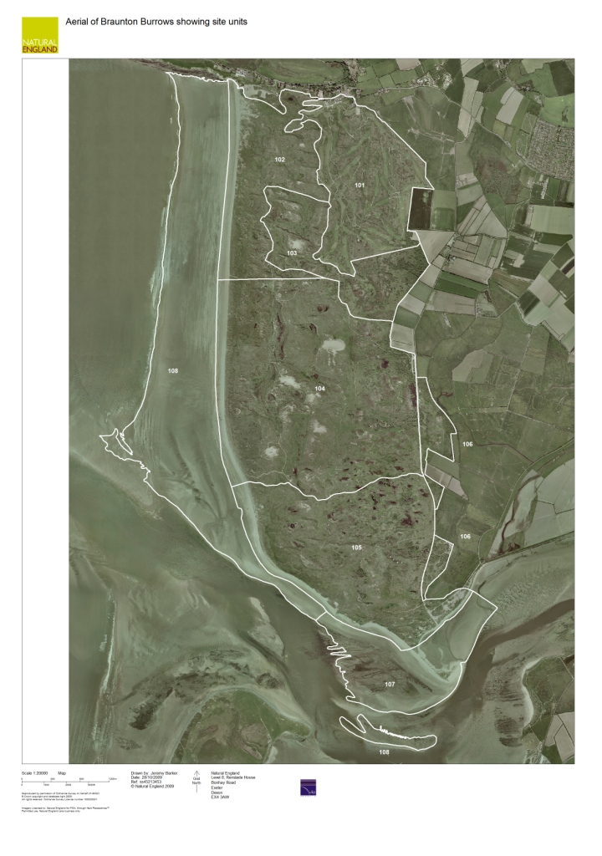

- Grazing compartments overlaying site units. Fence lines are approximate future boundaries for the two northern blocks.
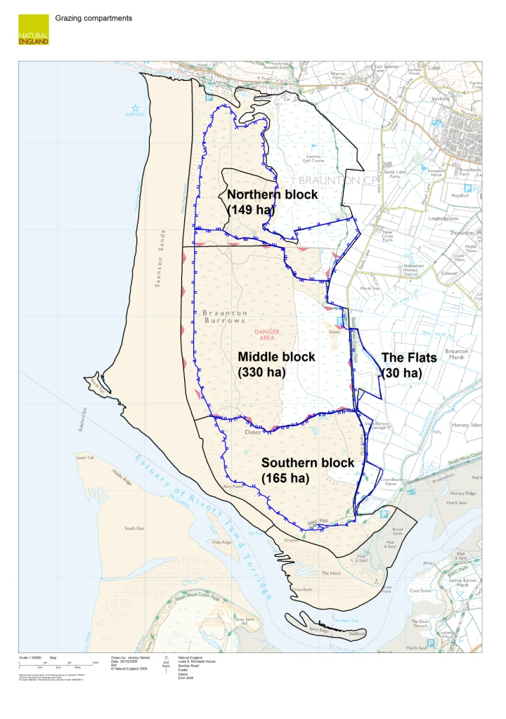

- Slacks for monitoring Sand-bowl Amber Snail Catinella arenaria.
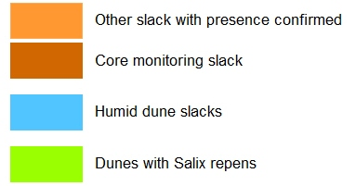
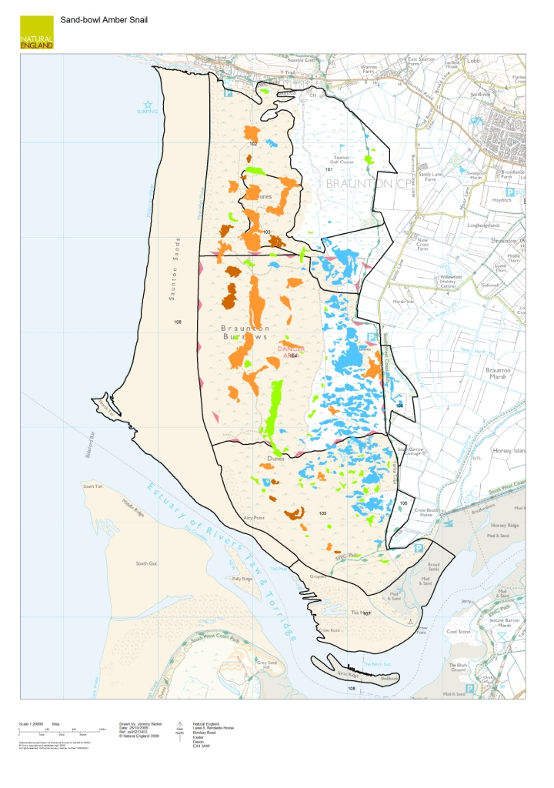

- Mapped species locations
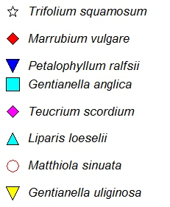
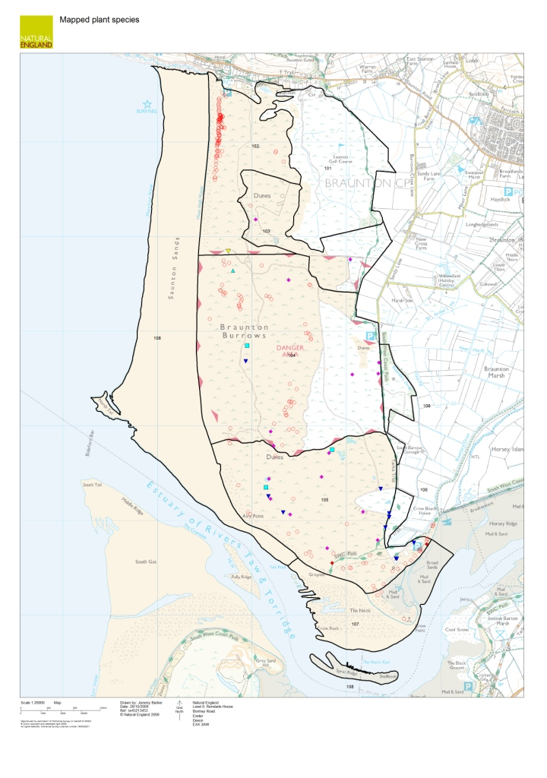

- Location of the priority lichen survey areas and notable species identified during scrub lichen survey (2007)
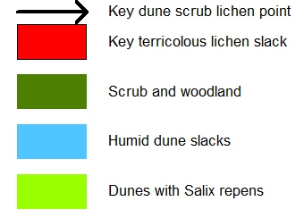
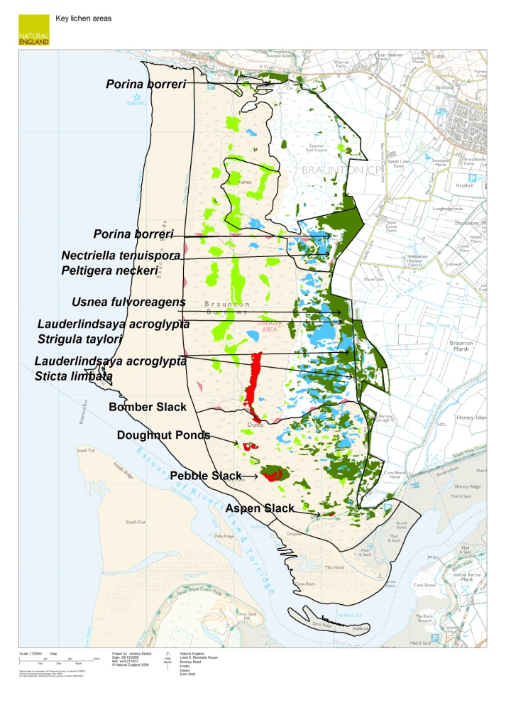

- Dipwell water monitoring transects
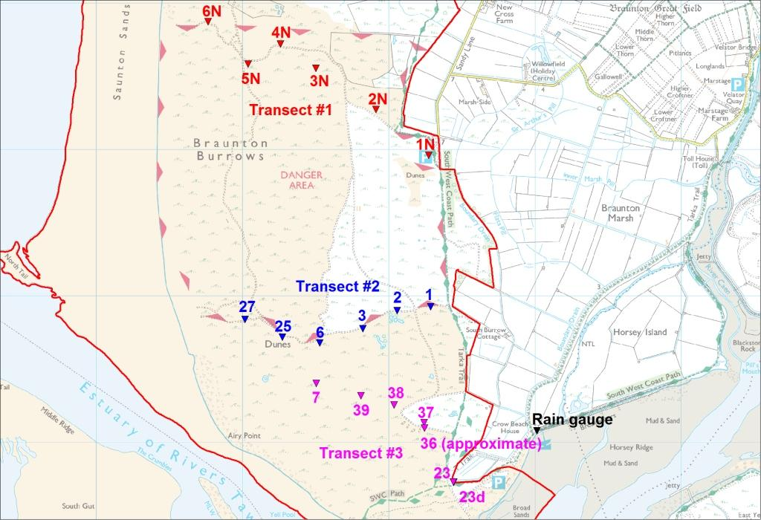

- Slacks used for trial grazing monitoring (red)
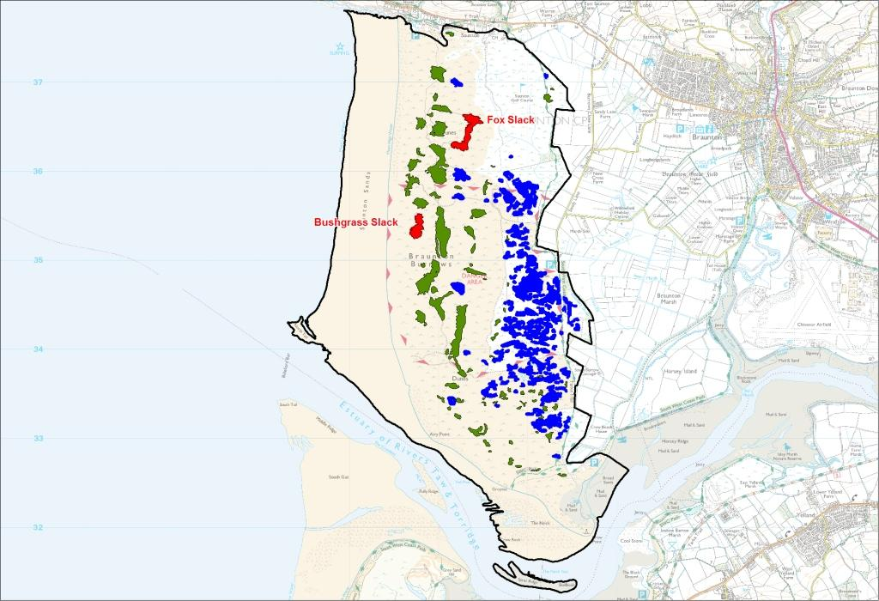
- Vegetation map.
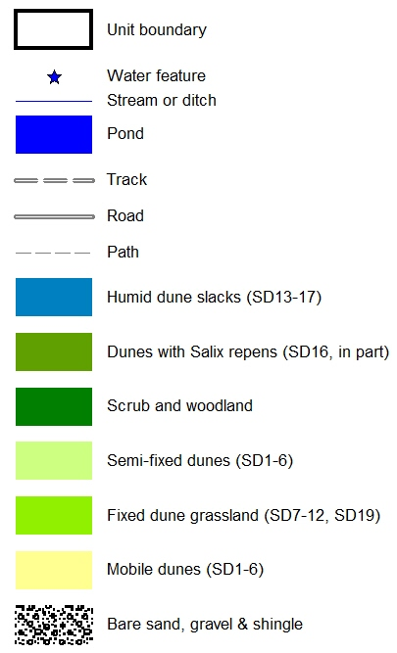
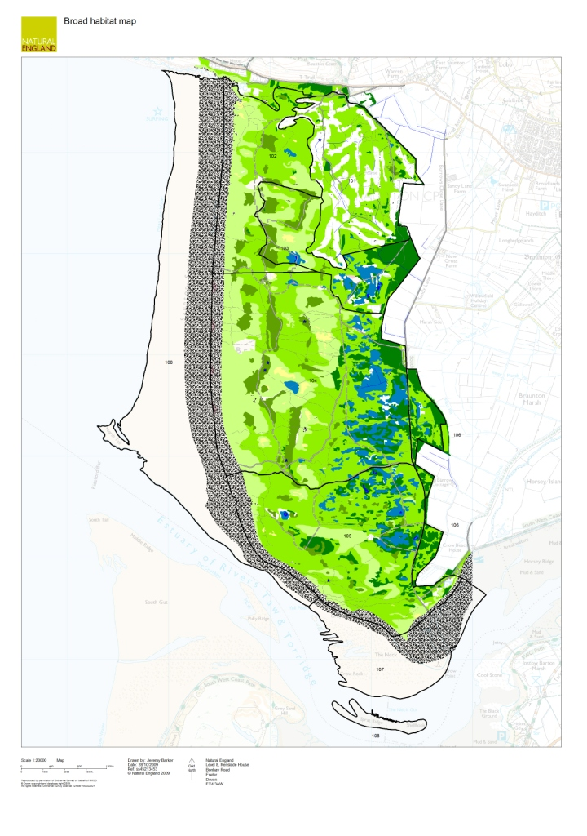

S:\Designated Sites\SSSI Sites\Braunton Burrows\Survey and Monitoring\Criteria Features\Amber sand bowl snail 2004\Final report and photos 2004
Dominant: the species appears >60% of stops and covers >50% of each sampling unit; Abundant: species occurs regularly throughout a stand, at >60% of stops and its cover is <50% of each sampling unit; Frequent: species recorded from 41-60% of stops; Occasional: species recorded from 21-40% of stops; and Rare: species recorded from <20% of stops

